

**Product Dissection for linkedIn**

### **Company Overview:**

LinkedIn is a business and employment-focused [social media platform](https://en.wikipedia.org/wiki/Social_media_platform) that works through websites and mobile apps. It was launched on May 5, 2003. Since December 2016, it has been a wholly owned subsidiary of [Microsoft](https://en.wikipedia.org/wiki/Microsoft). The platform is primarily used for professional networking and career development, and allows jobseekers to post their [CVs](https://en.wikipedia.org/wiki/Curriculum_vitae) and employers to post jobs. From 2015 most of the company's revenue came from [selling access to information about its members](https://en.wikipedia.org/wiki/Information_broker) to recruiters and sales professionals. LinkedIn has more than 970 million registered members from over 200 countries and territories.

LinkedIn allows members (both workers and employers) to create profiles and connect with each other in an online [social network](https://en.wikipedia.org/wiki/Social_network) which may represent real-world professional relationships. Members can invite anyone (whether an existing member or not) to become a connection. LinkedIn can also be used to organize offline events, join groups, write articles, publish job postings, post photos and videos, and more.

### **Product Dissection and Real-World Problems Solved by LinkedIn:**

LinkedIn, a transformative professional networking platform, has significantly contributed to addressing real-world challenges by providing a tailored space for career development and business networking. With a primary focus on connecting professionals, LinkedIn facilitates authentic engagement and fosters meaningful connections, bridging the gap between traditional networking and the demands of the modern professional landscape.

LinkedIn's core feature of professional profiles allows users to showcase their skills, experiences, and accomplishments, addressing the challenge of effectively representing oneself in a professional context. This feature serves as a dynamic digital resume, enabling users to build a compelling professional brand and connect with like-minded individuals in their industry.

The platform's emphasis on sharing industry insights, articles, and thought leadership through posts and articles addresses the need for staying informed and connected in a rapidly evolving business environment. By offering a space for professionals to share their knowledge and engage in discussions, LinkedIn provides a solution to the challenge of staying relevant and informed within one's professional sphere.

LinkedIn's innovative approach to job hunting and recruitment has transformed the traditional job search process. The platform's job listings, recommendations, and networking opportunities effectively address the challenges of finding relevant career opportunities and connecting with potential employers or collaborators.

Furthermore, LinkedIn's groups and communities create a space for professionals to engage in niche discussions, share experiences, and seek advice, offering a solution to the challenge of building a supportive professional network. The platform enables users to connect with individuals who share common interests, fostering collaboration and mentorship opportunities.

In conclusion, LinkedIn's product design has successfully addressed real-world challenges by providing a platform that caters to the unique needs of professionals. Through its features focused on professional profiles, knowledge sharing, job hunting, and networking, LinkedIn has become an indispensable tool for individuals looking to advance their careers, build meaningful connections, and stay abreast of industry trends in the ever-evolving professional landscape.

**Case Study: Real-World Problems and Linkedin’s Innovative Solutions**

LinkedIn, a leading professional networking platform, has revolutionized how individuals connect and navigate the business world. By leveraging innovative features, it addresses challenges through comprehensive profiles, fostering networking opportunities, and promoting effective self-promotion.

LinkedIn stands as a solution-driven platform that empowers individuals in their career journeys, fosters meaningful connections, and addresses real-world challenges within the dynamic landscape of professional interactions.

**Problem 1: Difficulty in finding jobs**

**Real world challenge:** as the whole world is going digital and carer options for job seekers are increasing day by day but it’s very difficult to explore the job opportunities open for them at one place.

**LinkedIn’s solution:**

Linked had created an in built job portal where the recruiter from different organisations post their job openings in linkedin and people from all over the world can explore and flexibly apply for their desired job type, location, experience and skills.

**Problem 2: Difficulty in finding desired candidate**

**Real world challenge**: recruiters from different organizations have different types and categories of job with varying skills and experience, but it will become very difficult for them to select from a pool of candidates that which candidate will be a perfect fit for the role.

**LinkedIn’s solution:** by the use of linkedin recruiter this problem is being solved. Linkedin recruiter provides a number a filters and tools so that one can select from a pool of candidates for the best available search. It can be done by applying Boolean search and then filtering the results based on the experience, distance of commute and previous job history.

**Problem 3: Lack of professional network**

**Real world challenge:** in the era of network one should have a good professional network. You are in network with your relevant industry experts, colleagues, and peers who are working with you to keep yourself updated the changing standard and technologies in your domain.

**LinkedIn solution:**

LinkedIn addresses the challenge of building and maintaining professional networks by providing a platform for users to connect with colleagues, industry peers, and potential collaborators, fostering meaningful connections to stay updates with the current industry standards

**Problem 4: Lack of platform for professional support.**

**Real world problem:** every individual from their specific domain or from other domain need help regarding some of their doubts regarding educational, professional, technical and non-technical problems but there isn’t any platform available in the market from where the user can find or ask the solution.

**Linkedin’s solution:**

Linkedin introduced a feature where user from all over the world can be a part of a digital community where industry experts, talented minds, CEOs, managers and other user came at a place known as linkedin community where anyone can post their doubts and questions and can find a number of solutions for the question. He/she can also participate in helping others by telling the answers to the doubts of others as per their knowledge. The community can be a used to spread awareness, find and post jobs, help individual regarding domain specific solutions etc..

#### **Conclusion:**

LinkedIn's evolution from a professional networking site to a global platform underscores its adeptness at identifying real-world challenges and delivering innovative solutions. By cultivating authentic professional connections, curating industry-specific content, nurturing creativity, and providing effective career help, LinkedIn has effectively addressed diverse challenges users face in the digital realm. This case study highlights how LinkedIn's user-focused strategy and persistent innovation have solidified its leadership in the professional networking space, fundamentally influencing the dynamics of online engagement and interaction within the business and career-oriented community.

### **Top Features of Linkedin:**

1. **User Profiles:** linkedin allows users to create personal profiles, offering insights into their lives through features such as full names, profile pictures, background picture, educational qualification, professional experience, and a brief introduction of yourself. It also provides a personal profile link individual for every user, this creates a personalised online presence that reflects each user's identity.
2. **Posts:** A core feature of linkedin is the ability to share photos, videos and career updates as posts. Users can add captions, tag peoples, and enhance their content using filters and hashtags.
3. **Interactions**: Engagement lies at the heart of linkedin. Users can express appreciation by liking posts, sharing their thoughts through comments and can repost so the connections may also see the post. The "Save" feature enables users to bookmark content for later viewing.
4. **Followers and connections:** The platform fosters connections through the "Follow" functionality. Users can follow other accounts to see their posts in their feed, creating a network of connections. Users can also view who is following them, enhancing transparency.
5. **Explore:** The "Explore" feature propels discovery by suggesting content based on user preferences and interactions. Users can explore posts, videos, and stories from accounts they don't follow, fostering a diverse online experience.
6. **Hashtags:** Users can add relevant hashtags to their posts, making them accessible to a broader audience. It also help in searching for posts which are been posted with the same hashtag.
7. **Recruiter and recruitment**: Linkedin offer a platform to all the users who are in search of a job or in search of peoples to fill their vacant positions of their company. By the use of linkedin job corner and linkedin recruiter corner it is very easy to search for the majority of jobs and candidates available in the market which can be further filtered using different tools available.

### **Schema Description:**

The schema for linkedin involves multiple entities that represent different aspects of the platform. These entities include Users, Posts, Comments, Likes, repost, Hashtags, and more. Each entity has specific attributes that describe its properties and relationships with other entities.

**User Entity:**

Users are at the core of linkedin. The user entity contains information about each user:

* **UserID (Primary Key)**: A unique identifier for each user.
* **Email**: The user's email address for account-related communication.
* **Full_Name**: The user's full name as displayed on their profile.
* **About:** A brief description that users can use to express themselves.
* **Registration_Date**: The date when the user joined Linkedin.
* **Current_designation**: Current designation/post the user is handling.

**Post Entity:**

Posts capture the visual content shared on the platform:

* **PostID (Primary Key):** A unique identifier for each post.
* **UserID (Foreign Key referencing User Entity**): The user who created the post.
* **Caption**: Text accompanying the post, providing context.
* **Image_vedio_URL**: The URL of the image or video content.
* **Post_Date**: The date when the post was created.

**Comment Entity:**

Comments enable users to engage in conversations around posts:

* **CommentID (Primary Key)**: A unique identifier for each comment.
* **PostID (Foreign Key referencing Post Entity):** The post being commented on.
* **UserID (Foreign Key referencing User Entity)**: The user who posted the comment.
* **Text**: The text of the comment.
* **Comment_Date**: The date when the comment was posted.

**Like Entity:**

Likes represent user appreciation for posts:

* **LikeID (Primary Key):** A unique identifier for each like.
* **PostID (Foreign Key referencing Post Entity):** The post being liked.
* **UserID (Foreign Key referencing User Entity):** The user who liked the post.
* **Like_Date:** The date when the like was registered.

**Hashtag Entity:**

Hashtags categorise and group content:

* **HashtagID (Primary Key):** A unique identifier for each hashtag.
* **PostID (Foreign Key referencing Post Entity):** The post over which the hashtag is being used.
* **Tag**: The actual text of the hashtag.

**Reshare Entity:**

Associates posts resharing

* **ReshareID (primary key):** A unique identifier for each reshare.
* **PostID (Foreign Key referencing Post Entity):** The post being reshared.
* **UserID (Foreign Key referencing User Entity):** The user who created the post.
* **Reshare_date:** date on which the post is being reshared.

**Community Entity:**

Social groups to spread resources and help among users

* **CommunityID (Primary key**): A unique identifier for each community.
* **UserID: (Foreign Key referencing User Entity):** The user who is the member of the community.
* **User_joining_date**: date on which user joined the community.

**Relationships are:**

* **Users post Posts –** Each user can post multiple posts.
* **Users comment on Posts –** Users can comment on multiple posts, and each post can have multiple comments.
* **Users like Posts –** Users can like multiple posts, and each post can have multiple likes.
* **Posts have Hashtags –** Posts can have multiple hashtags, and each hashtag can be associated with multiple posts.
* **Posts are reshared –** user can reshare multiple posts and each post can be shared by multiple users.
* **Users join community –** users can multiple community and each community is been followed by multiple users.

**ER Diagram:**

Let's construct an ER diagram that vividly portrays the relationships and attributes of the entities within the Linkedin schema. This ER diagram will serve as a visual representation, shedding light on the pivotal components of Linkedin’s data model. By employing this diagram, you'll gain a clearer grasp of the intricate interactions and connections that define the platform's dynamics.

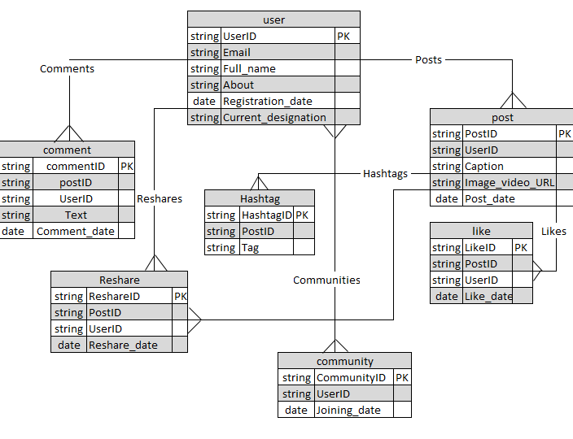

**Conclusion:**

In this case study, we have explored the intricacies of LinkedIn's schema and Entity-Relationship diagram, shedding light on the platform's innovative approach to professional networking and career development. LinkedIn has transformed the way individuals connect, collaborate, and advance in their professional lives, providing a unique space for networking, skill development, and job opportunities. The well-designed data model encompasses entities such as users, profiles, connections, posts, endorsements, companies, and job listings, forming the backbone of LinkedIn's seamless functionality. By dissecting this schema, we gain valuable insights into how LinkedIn efficiently manages the complexities of professional interactions and content sharing the platform's emphasis on professional growth and collaboration is evident in its data structure, contributing to its widespread adoption and success in the realm of professional social networking.